International Cybersecurity and Digital Forensics Academy (ICDFA)
CIP-B103: Network Forensics Fundamentals
LAB 7: DNS Introduction and Traffic Analysis
Three-Week Delivery Block 3/3 | 1-2 August 2026
Prepared by: Aminu Idris, AMCPN | Founder, ICDFA
Important Pre-Lab Instruction
Read the matching lecture slide deck before executing the practical. Work only inside the ICDFA-approved lab or your own isolated virtual environment. Record every command, observation and screenshot as contemporaneous evidence.
Course Code | CIP-B103
Course Title | Network Forensics Fundamentals
Lab Number | Lab 7
Lab Title | DNS Introduction and Traffic Analysis
Student Name | Fuseini Imoru Kantuogaa
Student ID | 17291
Instructor Name | Dr. Sarah James
Delivery Block | 3/3 of 3
Scheduled Dates | 1-2 August 2026
Estimated Duration | 3-4 hours practical work plus report writing
Mode | Individual practical lab in an authorized virtual environment
Required Evidence | dig_dns.pcap or locally generated DNS captures; optional smtp.pcap correlation

1. Source Materials and Slide Alignment
- Domain Name System Forensics: domain-to-IP resolution, hierarchical DNS, resolver/TLD/authoritative roles, dig queries, capture with tshark, query/response fields and DNS within email traffic.
- The slide practical captures dig and browser DNS traffic, examines A records, local resolver configuration, TTL and authoritative information.
- The exercise builds the normal DNS baseline required before analyzing spoofing in Lab 8.
Reading Requirement Before Lab Execution
The lab deliberately follows the sequence, terminology and core exercises presented in the uploaded CIP-B103 slides. Commands have been corrected where needed for Linux syntax and forensic repeatability.

2. Lab Scenario
You are documenting normal DNS behaviour for an incident-response baseline. You will identify the configured resolver, capture controlled dig queries, analyze transaction IDs, names, record types, response codes, answers and TTL values, and correlate DNS resolution with a subsequent web or email connection.

3. Learning Outcomes
- Explain recursive and iterative DNS resolution at a foundational level.
- Use dig to query A, AAAA, MX and NS records.
- Capture and analyze DNS queries and responses with tshark/Wireshark.
- Identify transaction ID, query name, record type, response code, answer and TTL.
- Correlate DNS responses with later IP connections.
- Recognize normal variations such as multiple answers, CNAMEs, cache responses and IPv6 queries.

4. Legal, Ethical and Safety Rules
- Use only systems, packet captures and networks for which you have explicit authorization.
- Keep the lab isolated from production, campus, office and public networks. Use NAT or host-only virtual networking as instructed.
- Do not collect, disclose or reuse real credentials, personal messages or confidential traffic.
- Preserve original capture files. Perform analysis on verified working copies and record SHA-256 hashes.
- Stop any traffic-generation or interception process immediately after the required evidence is captured.
- Restore firewall, ARP, forwarding and network settings before closing the lab.

5. Required Tools and Environment
Item | Recommended Tool | Purpose
Operating system | Kali Linux or Ubuntu VM | Generate and analyze DNS traffic.
DNS utility | dig from dnsutils | Perform controlled queries.
Capture tools | tshark and Wireshark | Capture DNS traffic.
Evidence | dig_dns.pcap or new PCAPNG | Analysis source.
Resolver config | /etc/resolv.conf, resolvectl | Identify configured DNS service.
Optional browser | Firefox/Chrome | Generate multiple DNS lookups.

6. Lab Folder Structure and Evidence Preparation
mkdir -p ~/CIP-B103-Lab7/{evidence,working,exported,reports,screenshots,scripts}
cd ~/CIP-B103-Lab7
pwd
find . -maxdepth 1 -type d -print
Create the folder structure before downloading or generating evidence. Store original captures under evidence and analysis copies under working.
sudo apt update
sudo apt install -y dnsutils tshark wireshark
cat /etc/resolv.conf | tee reports/resolv_conf.txt
resolvectl status 2>/dev/null | tee reports/resolvectl_status.txt || true
wget -O evidence/dig_dns.pcap \
'https://raw.githubusercontent.com/frankwxu/digital-forensics-lab/main/Networking_Forensics/lab_files/dns/dig_dns.pcap'
cp --preserve=timestamps evidence/dig_dns.pcap working/dig_dns_working.pcap
sha256sum evidence/dig_dns.pcap working/dig_dns_working.pcap | tee reports/dns_capture_hashes.txt
Screenshot required: Configured resolver information, evidence details and hashes.
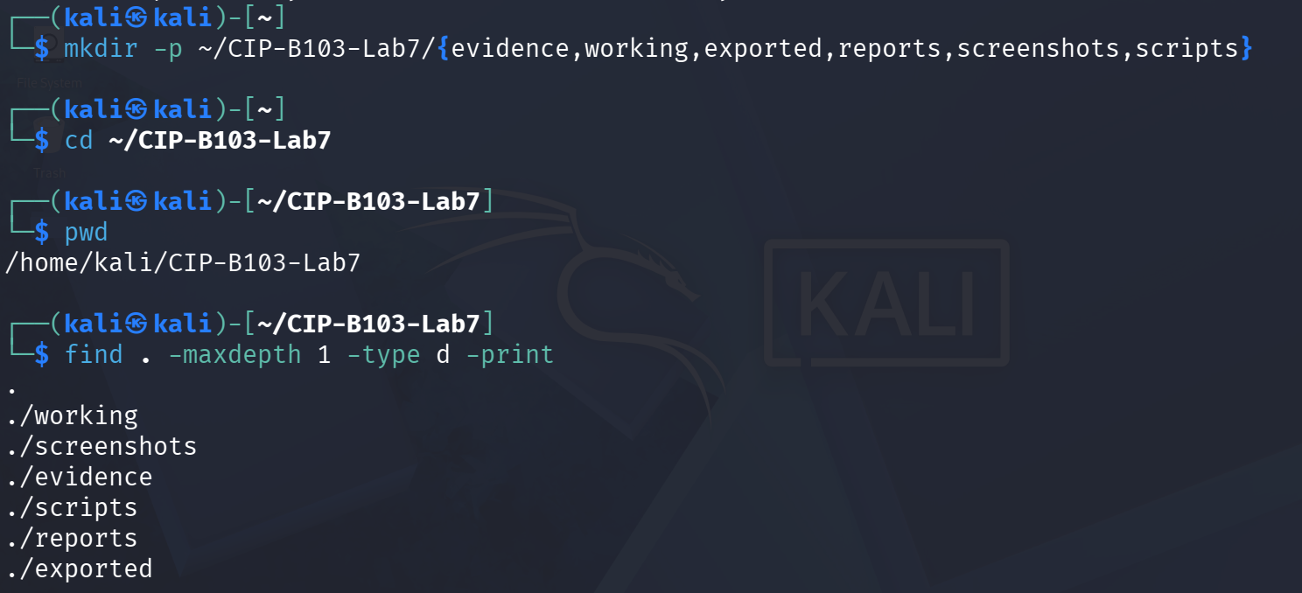
Screenshot 1: Evidence folder structure created (mkdir, cd, pwd, find).
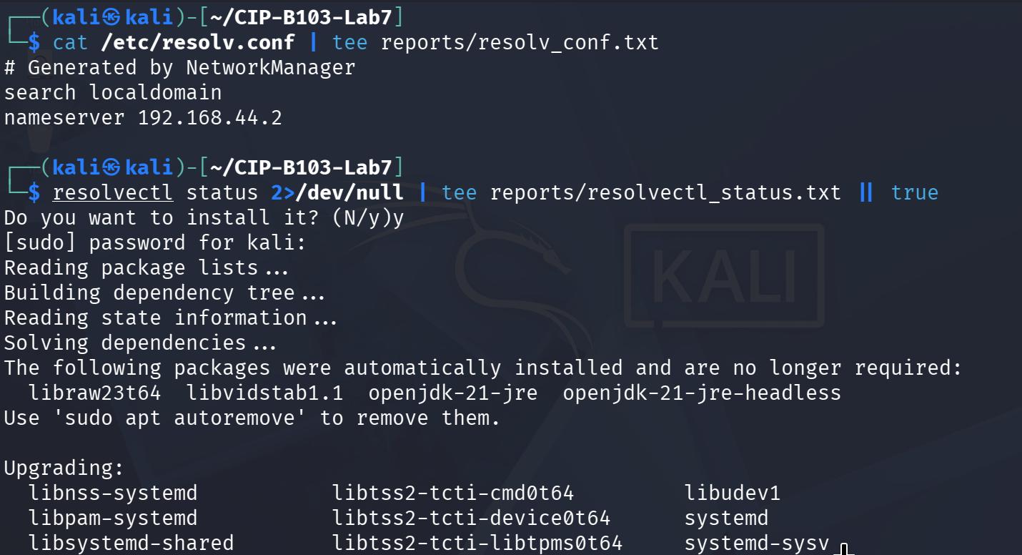
Screenshot 2: /etc/resolv.conf recorded and systemd-resolved installation started.
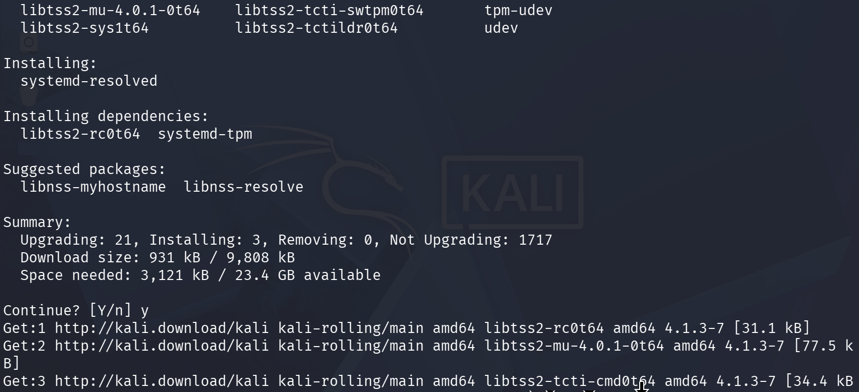
Screenshot 3: systemd-resolved package installation continued.
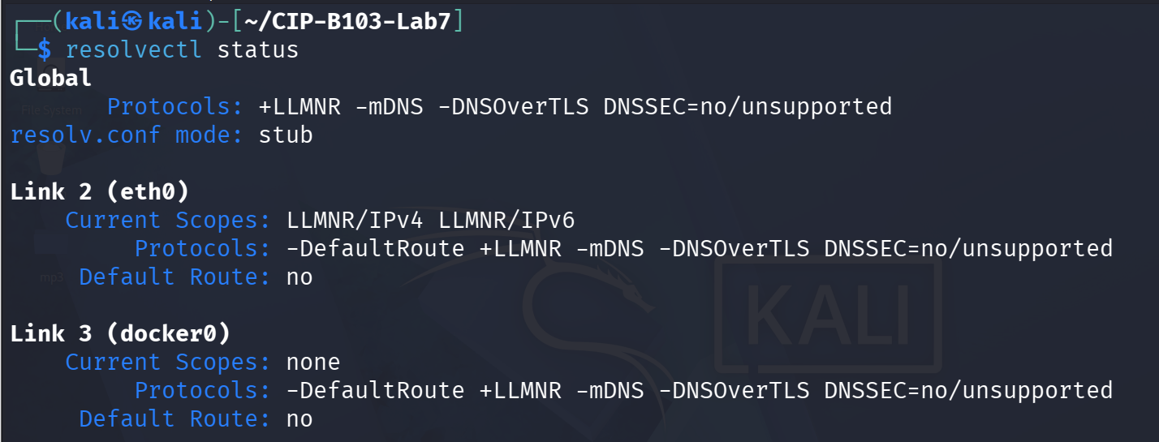
Screenshot 4: resolvectl status showing the stub resolver and per-link protocol scopes.
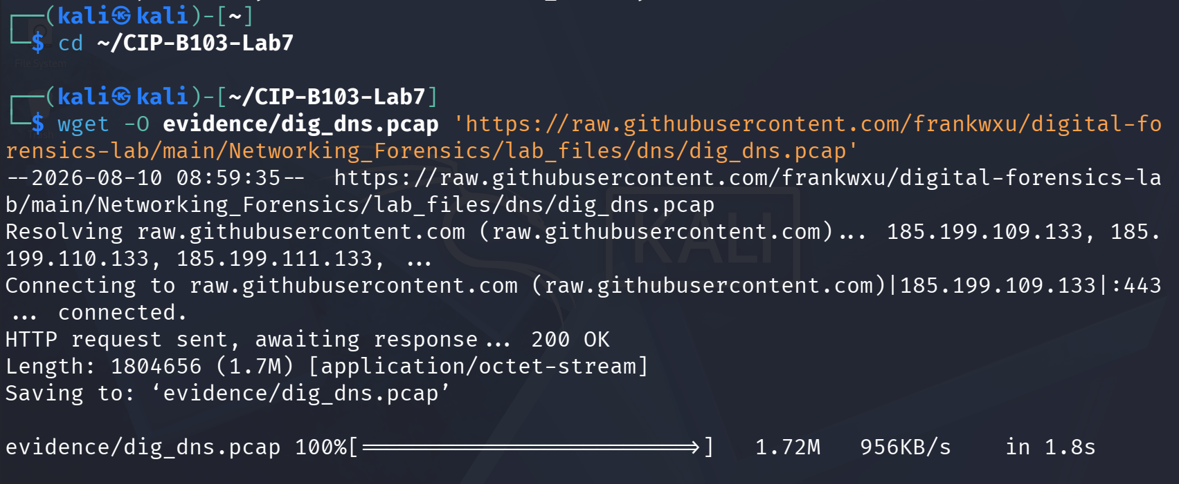
Screenshot 5: dig_dns.pcap downloaded via wget from the course GitHub repository.
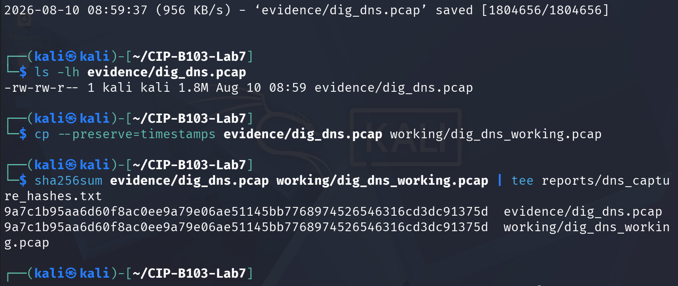
Screenshot 6: Evidence file listed, copied to a working copy, and SHA-256 hashed (evidence and working copy identical).
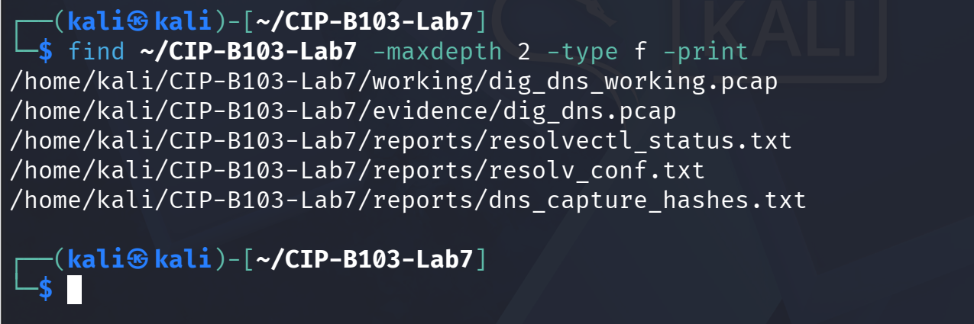
Screenshot 7: Evidence folder contents confirmed via find.

7. Mini Evidence and Chain-of-Custody Worksheet
Field | Student Entry
Case/lab identifier | CIP-B103-Lab7- Fuseini Imoru Kantuogaa
Trainee name | Fuseini Imoru Kantuogaa
Date and time started | Mon 10 August 2026, approx. 08:59 EDT (Kali VM) — timestamp of the wget download of the reference evidence file
Evidence file name(s) | dig_dns.pcap (working copy: dig_dns_working.pcap); locally generated evidence/fresh_dig_dns.pcapng and evidence/browser_dns.pcapng
Source or generation method | dig_dns.pcap downloaded via wget from the frankwxu digital-forensics-lab GitHub repository (supplied reference evidence); fresh_dig_dns.pcapng and browser_dns.pcapng captured locally with tshark while running dig and browsing Firefox
Original SHA-256 | dig_dns.pcap: 9a7c1b95aa6d60f8ac0ee9a79e06ae51145bb7768974526546316cd3dc91375d; fresh_dig_dns.pcapng: 70f60ab2c65fb1e10746f4da32af9895038a4fe5c9765ef72a08ebf7b4dc05aa; browser_dns.pcapng: b1a1d3a79210775d564539200312ee8e6c2f6173cd5fe7bce0bcc659c271de84
Working-copy SHA-256 | dig_dns_working.pcap: 9a7c1b95aa6d60f8ac0ee9a79e06ae51145bb7768974526546316cd3dc91375d — identical to original
Analysis workstation/VM | Kali Linux (user: kali), CIP-B103-Lab7 working directory; resolver 127.0.0.53 (systemd-resolved stub) forwarding to 192.168.44.2
Notes on any changes | cp --preserve=timestamps used for the working copy; SHA-256 of evidence and working copies matched exactly. tshark -i any produced a harmless ‘promiscuous mode not supported’ warning for the fresh capture but still recorded all 4 packets. The supplied dig_dns.pcap reference file was hashed but not directly analyzed with tshark in the available screenshots — analysis instead focused on the locally generated fresh_dig_dns.pcapng and browser_dns.pcapng.

8. Part A - Query DNS Records with dig
dig example.com A | tee reports/dig_example_A.txt
dig example.com AAAA | tee reports/dig_example_AAAA.txt
dig example.com MX | tee reports/dig_example_MX.txt
dig example.com NS | tee reports/dig_example_NS.txt
dig +short example.com A | tee reports/dig_example_short.txt
- Record the resolver shown in the SERVER line.
- Record status/response code, flags, question count, answer count and query time.
- Explain IN, A, AAAA, MX and NS.
- Record at least one TTL and explain that it is a cache lifetime, not a creation date.
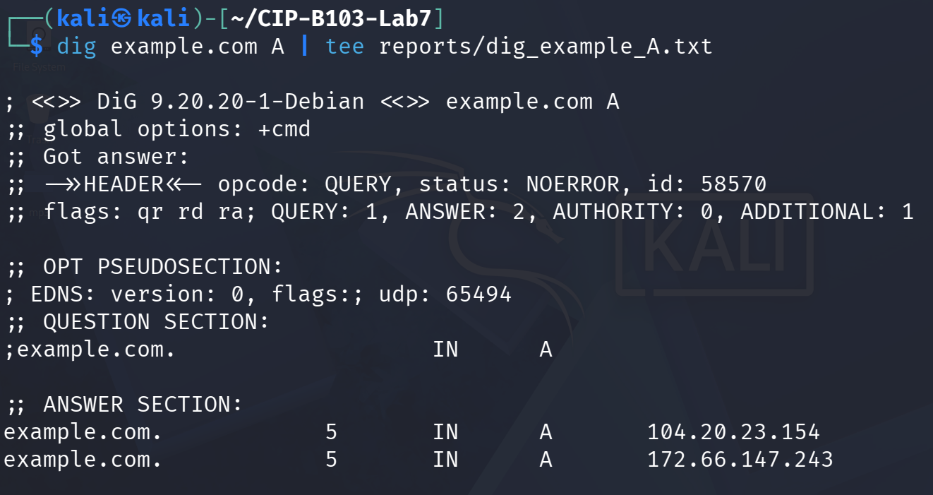
Screenshot 8: dig example.com A executed and piped to reports/dig_example_A.txt.
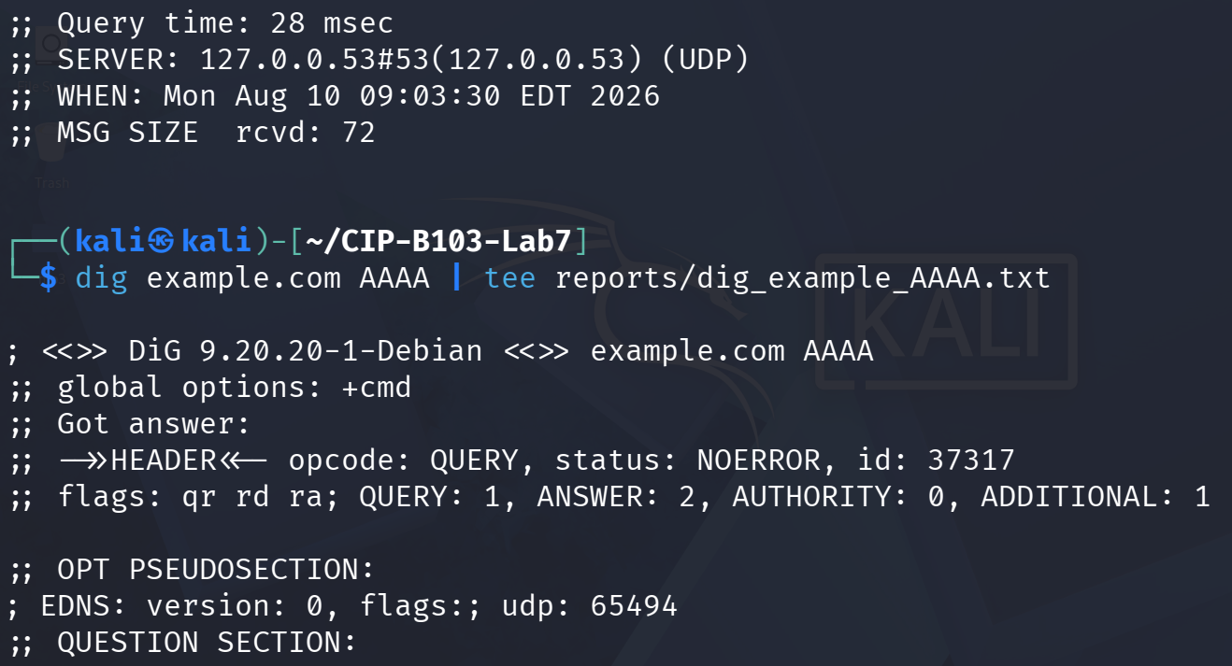
Screenshot 9: A-record answer section and query time; dig example.com AAAA started.
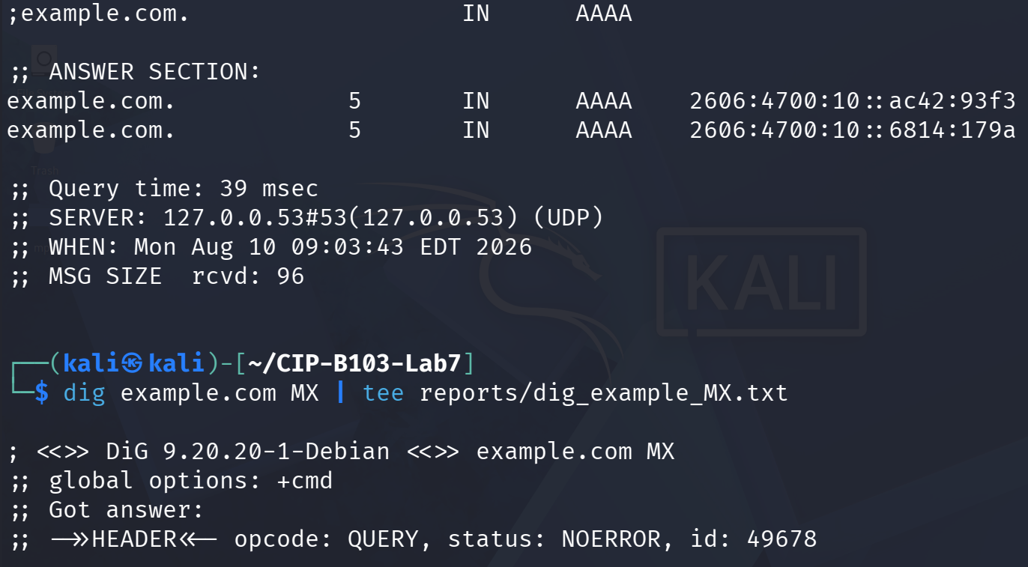
Screenshot 10: AAAA answer section; dig example.com MX started.
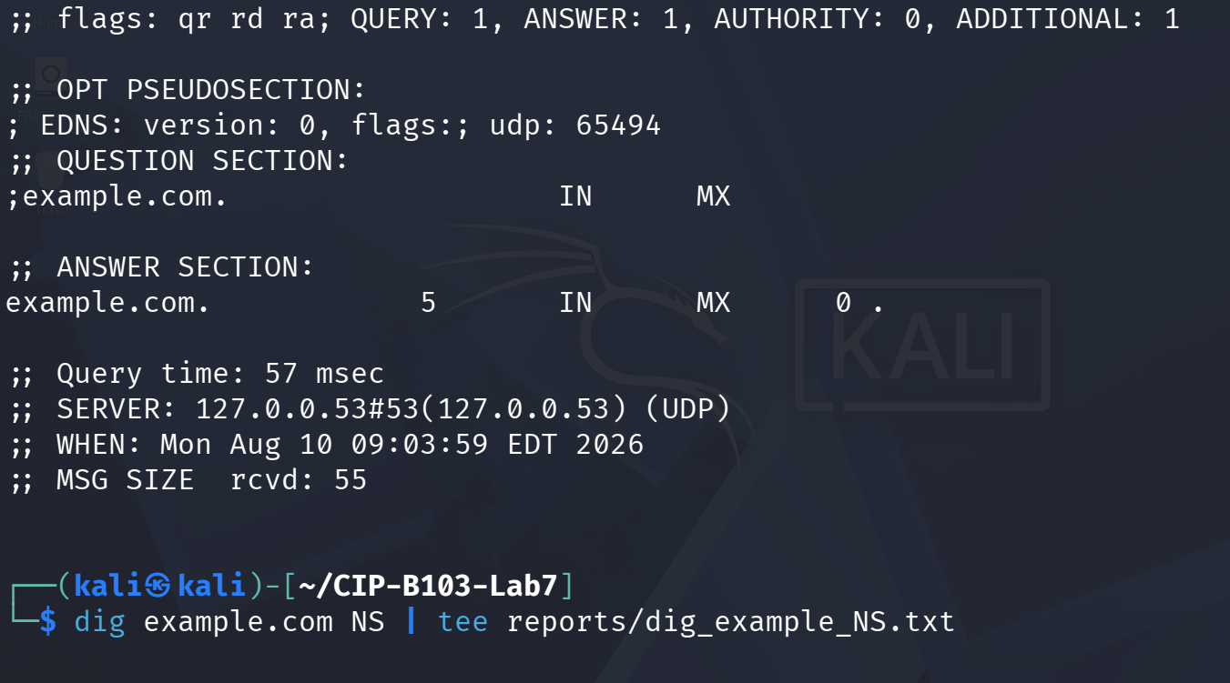
Screenshot 11: MX answer section; dig example.com NS started.
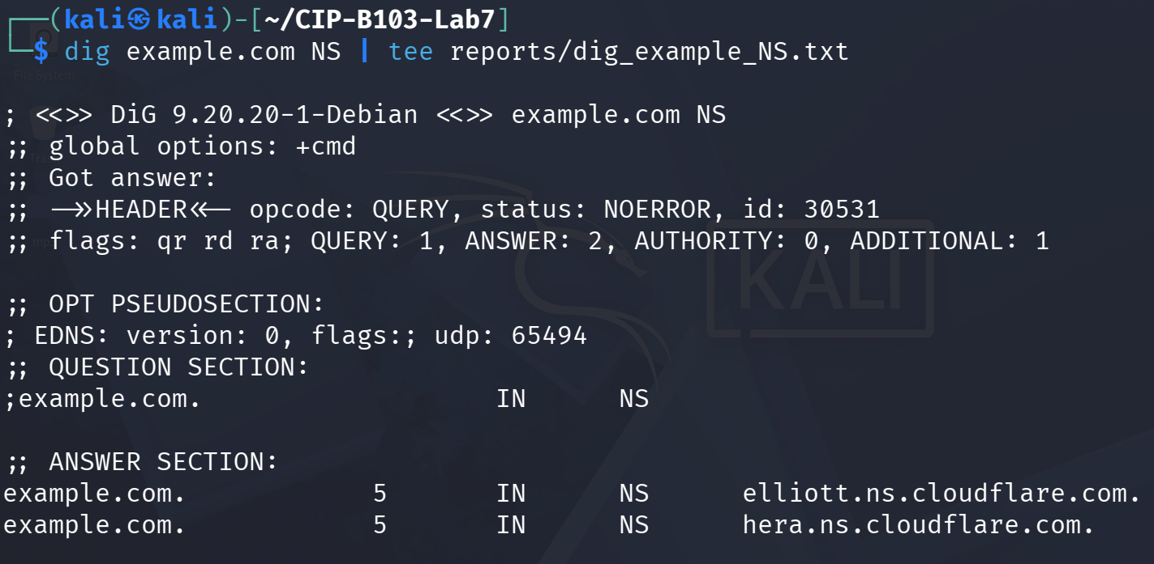
Screenshot 12: NS answer section listing the authoritative Cloudflare nameservers.
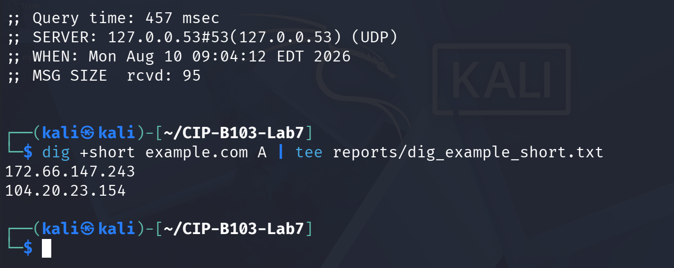
Screenshot 13: NS query time/server; dig +short example.com A showing the bare IP answers.

9. Part B - Capture a Fresh DNS Query
IFACE=eth0
sudo tshark -i "$IFACE" -f 'port 53' -a duration:25 -w evidence/fresh_dig_dns.pcapng &
sleep 3
dig +noedns example.com A >/dev/null
wait
sha256sum evidence/fresh_dig_dns.pcapng | tee reports/fresh_dns_sha256.txt
Interface Note
On systems using a local stub resolver, packets may appear on lo and then on a physical interface. Use tshark -D to list interfaces and choose the one that shows the actual query.
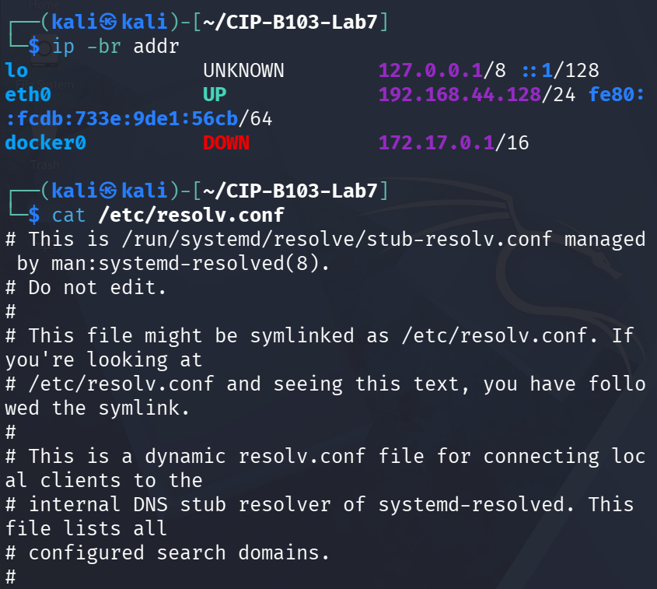
Screenshot 14: Interface addresses and full resolv.conf (systemd-resolved stub) confirmed; IFACE set to any.
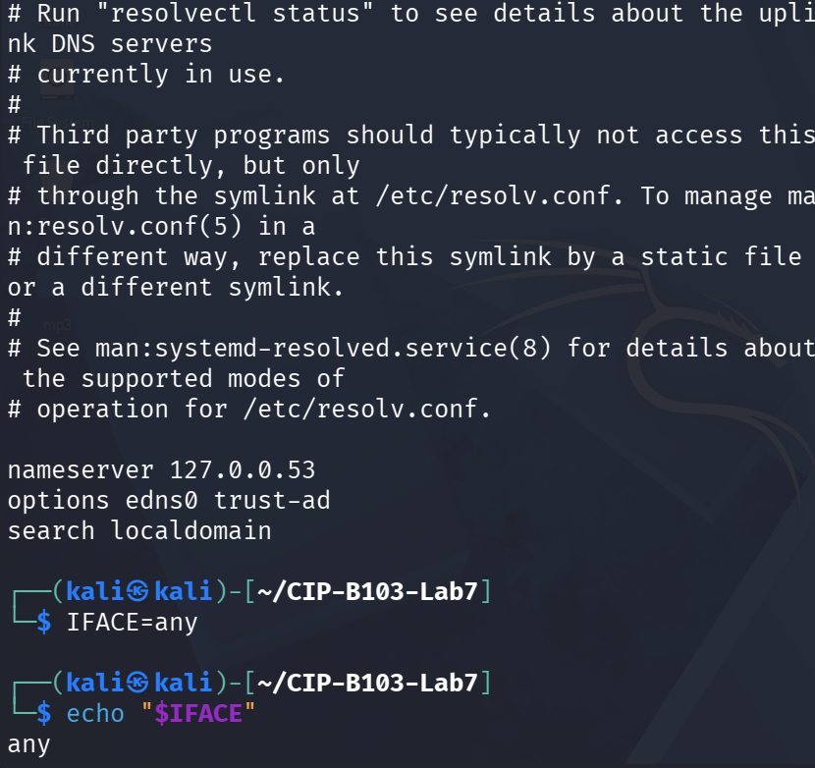
Screenshot 15: Fresh DNS capture started on interface any (port 53, 30 s).
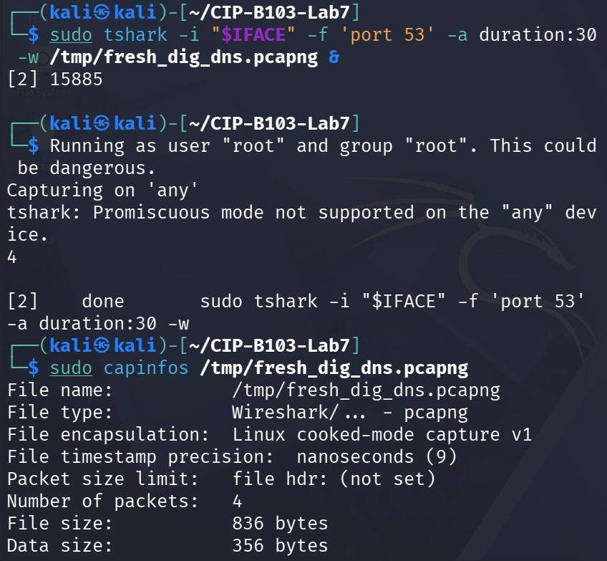
Screenshot 16: capinfos on the fresh capture confirming 4 packets captured.
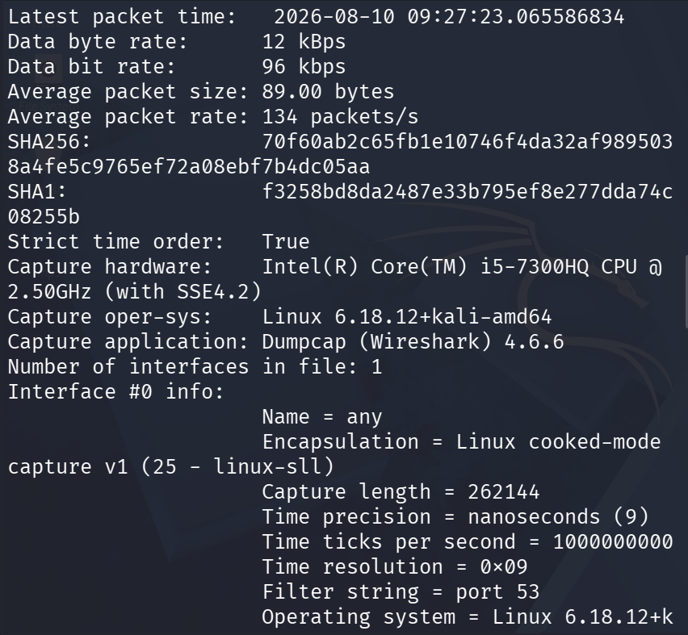
Screenshot 17: capinfos continued — SHA256/SHA1 and interface metadata.
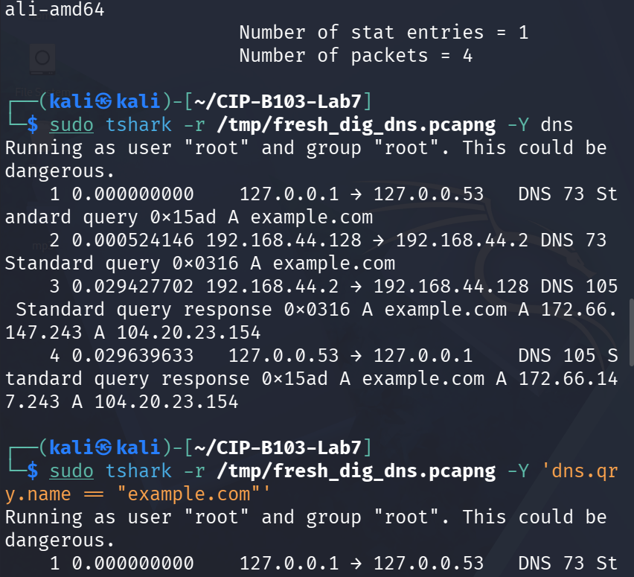
Screenshot 18: capinfos concluded; tshark -Y dns listing all 4 query/response frames.
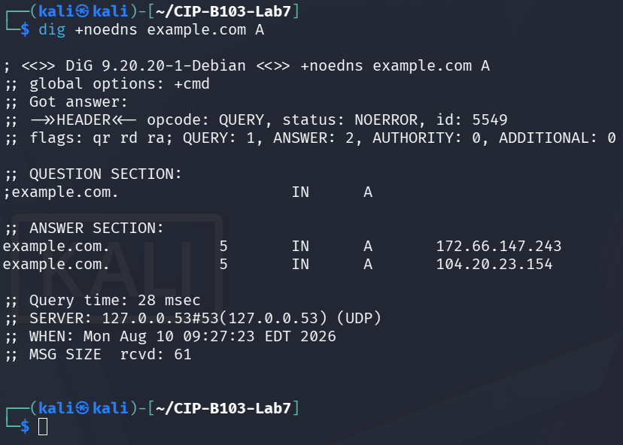
Screenshot 19: dig +noedns example.com A executed to generate the analyzed query.
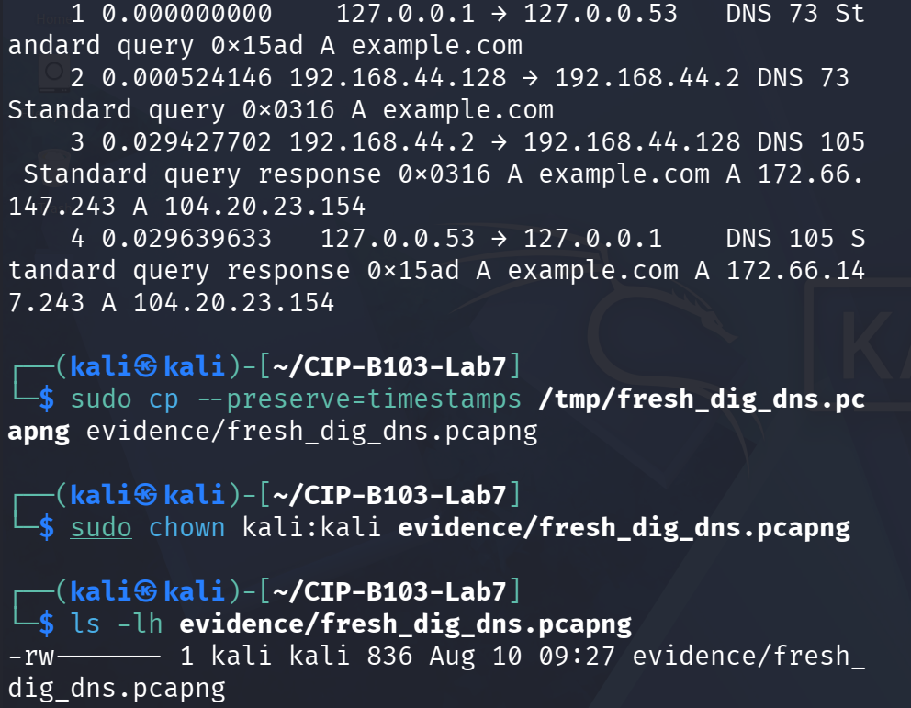
Screenshot 20: Frame listing repeated; capture copied and chown'd to evidence/.
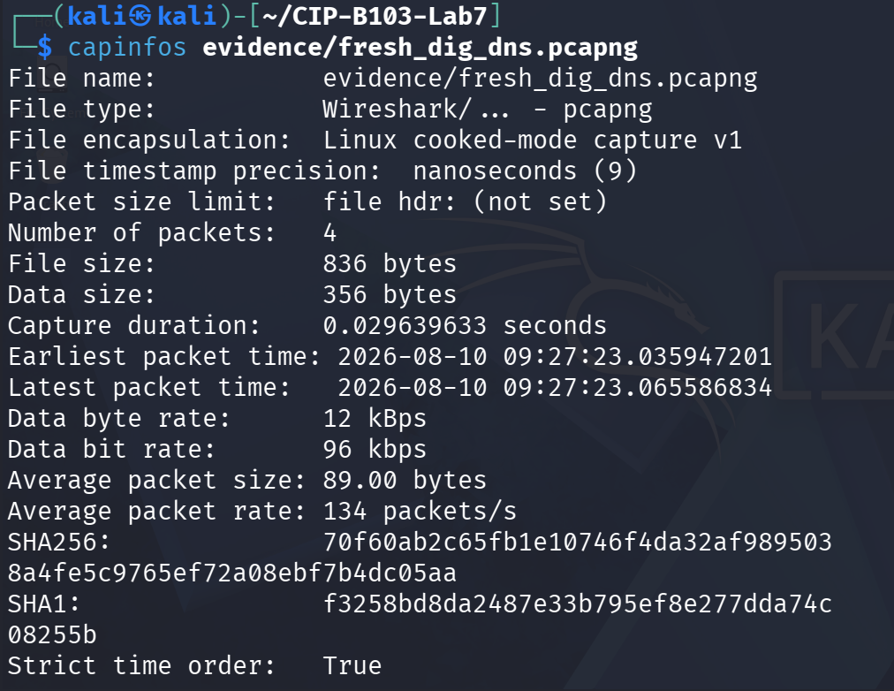
Screenshot 21: evidence/fresh_dig_dns.pcapng listed; capinfos re-run on the evidence copy.
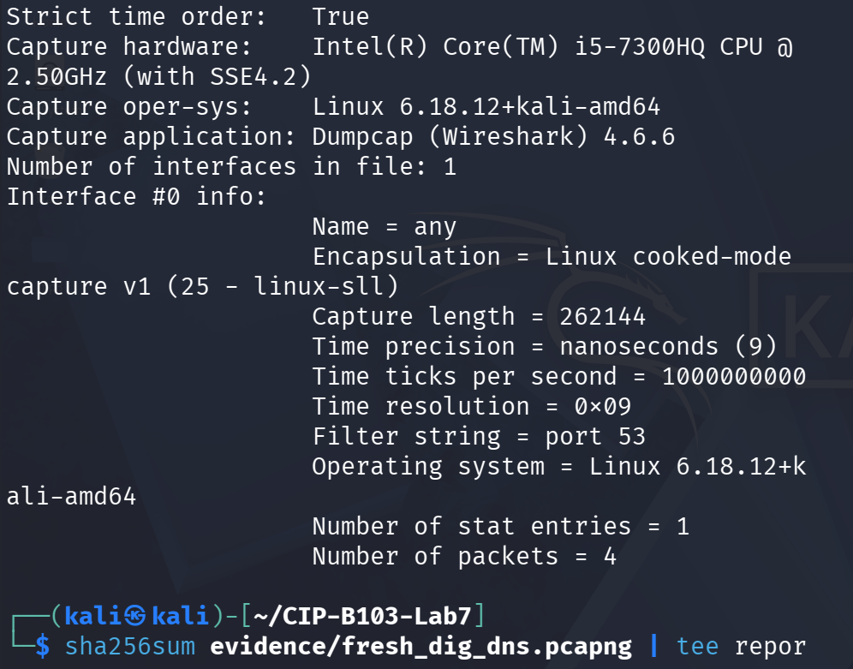
Screenshot 22: capinfos continued — timestamps, SHA256/SHA1 and interface metadata.
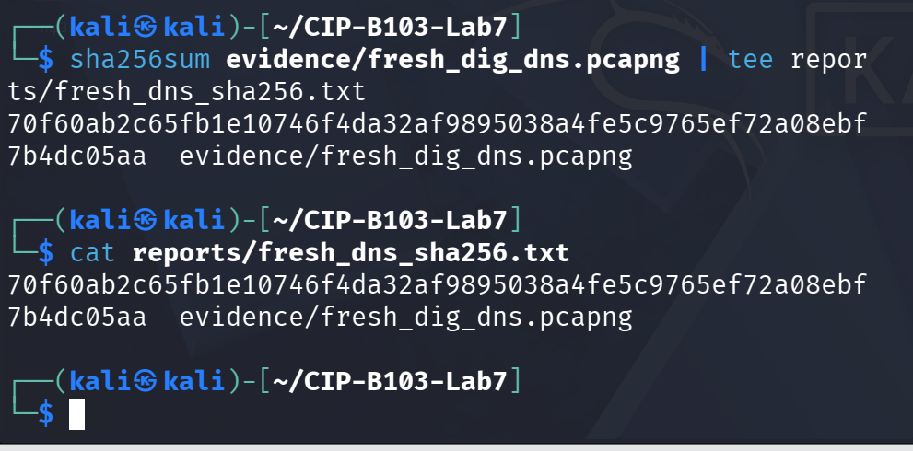
Screenshot 23: evidence/fresh_dig_dns.pcapng SHA-256 hashed and confirmed via cat.

10. Part C - Extract DNS Query and Response Fields
PCAP=evidence/fresh_dig_dns.pcapng
# Query
tshark -r "$PCAP" -Y 'dns.flags.response==0' -T fields \
-e frame.number -e frame.time -e ip.src -e udp.srcport -e ip.dst -e udp.dstport \
-e dns.id -e dns.qry.name -e dns.qry.type \
| tee reports/dns_queries.tsv
# Response
tshark -r "$PCAP" -Y 'dns.flags.response==1' -T fields \
-e frame.number -e frame.time -e ip.src -e udp.srcport -e ip.dst -e udp.dstport \
-e dns.id -e dns.flags.rcode -e dns.count.answers -e dns.a -e dns.aaaa -e dns.resp.ttl \
| tee reports/dns_responses.tsv
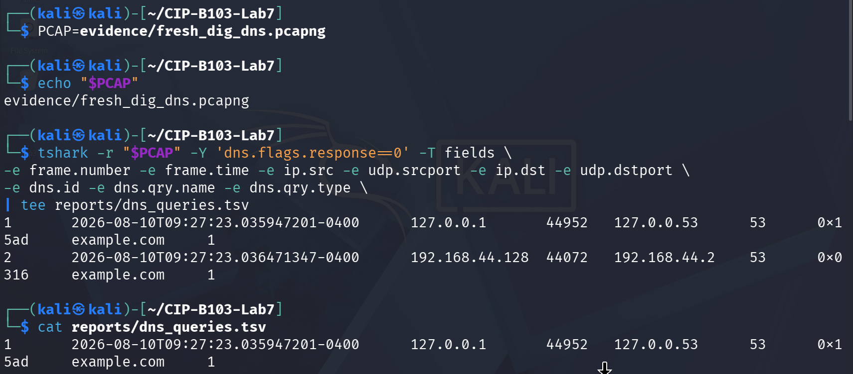
Screenshot 24: dns.flags.response==0 field extraction showing both DNS query legs (stub and upstream).
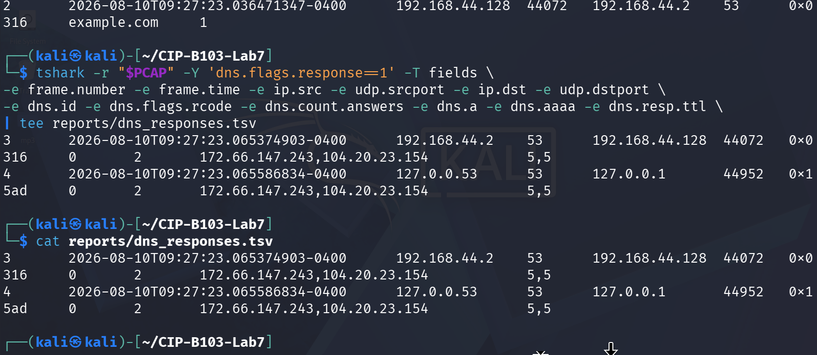
Screenshot 25: dns.flags.response==1 field extraction showing both DNS response legs with answers and TTLs.
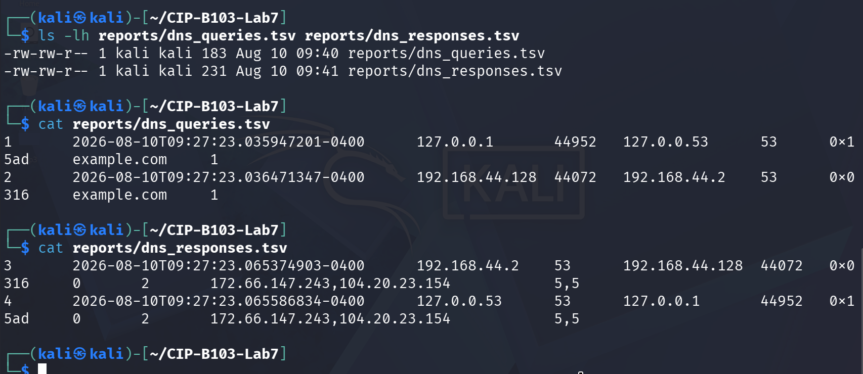
Screenshot 26: reports/dns_queries.tsv and reports/dns_responses.tsv confirmed via ls and cat.

11. Part D - Match Queries to Responses
Transaction ID | Query Name | Type | Client/Resolver | Response Code | Answer(s) | TTL | Time Delta
0x15ad | example.com | A | 127.0.0.1:44952 → 127.0.0.53:53 (stub resolver) | NOERROR (0) | 172.66.147.243, 104.20.23.154 | 5 s (both answers) | 29.639 ms (frame 1 → frame 4, 0.000000000 → 0.029639633 s)
0x0316 | example.com | A | 192.168.44.128:44072 → 192.168.44.2:53 (upstream/gateway resolver) | NOERROR (0) | 172.66.147.243, 104.20.23.154 | 5 s (both answers) | 28.903 ms (frame 2 → frame 3, 0.000524146 → 0.029427702 s)
Both IDs confirmed distinct per leg (0x15ad stub, 0x0316 upstream) | example.com (dig +noedns example.com A) | A | Two-hop resolution: client → local stub (127.0.0.53) → upstream resolver (192.168.44.2) | NOERROR for both legs | Identical answer set on both legs: 172.66.147.243, 104.20.23.154 | 5 s uniformly | Overall round trip ≈ 29.6 ms from initial stub query to final stub response
- Match query and response using transaction ID plus the endpoint tuple.
- Confirm that the response source is the queried resolver.
- Calculate response time from frame timestamps.
- Document CNAME chains and multiple A/AAAA answers where present.

12. Part E - Analyze DNS Generated by a Browser
A browser may request several domains for the page, images, fonts, telemetry or cached services. Capture a visit to a non-sensitive instructor-approved site and inventory all query names.
sudo tshark -i IFACE -f 'port 53' -a duration:40 -w evidence/browser_dns.pcapng &
sleep 3
# Open the approved site in a private browser window, then wait.
wait
tshark -r evidence/browser_dns.pcapng -Y 'dns.flags.response==0' -T fields -e dns.qry.name -e dns.qry.type \
| sort | uniq -c | sort -nr | tee reports/browser_dns_inventory.txt
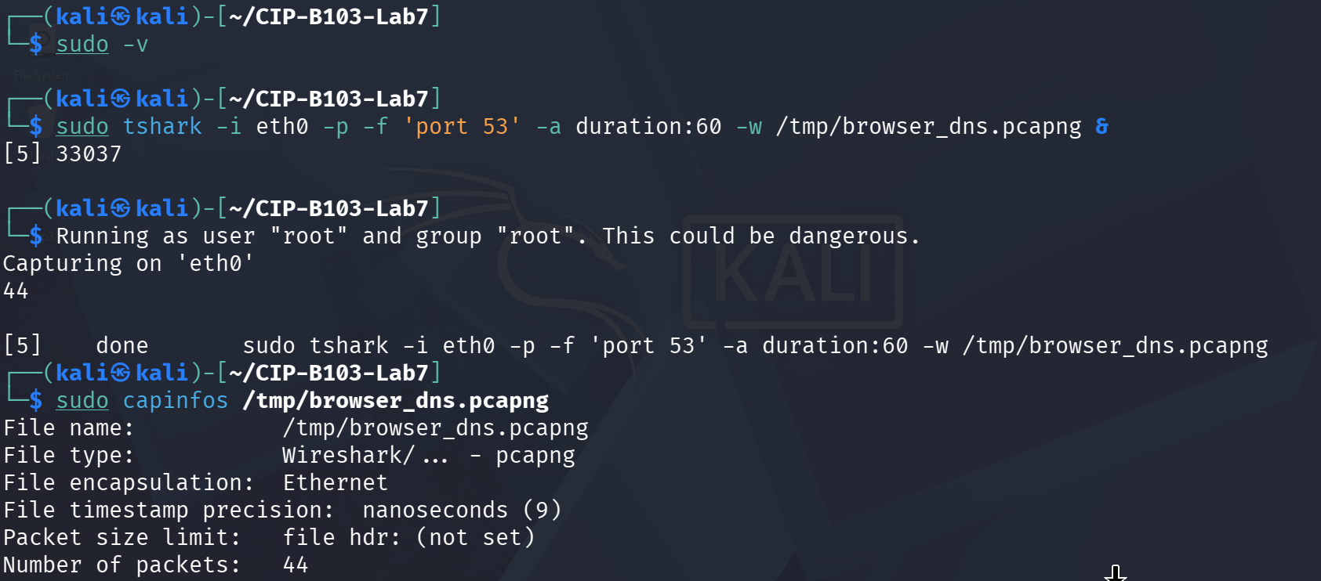
Screenshot 27: Browser DNS capture started on eth0 (port 53, 60 s).
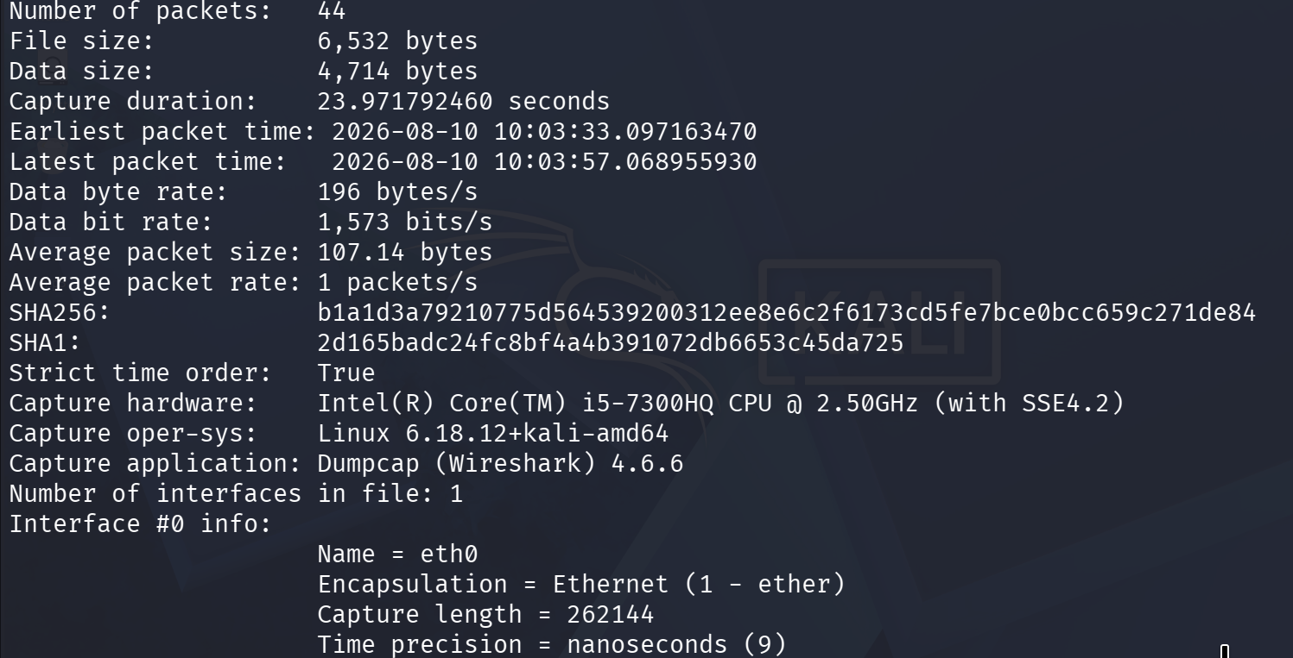
Screenshot 28: capinfos on the raw browser capture confirming 44 packets.
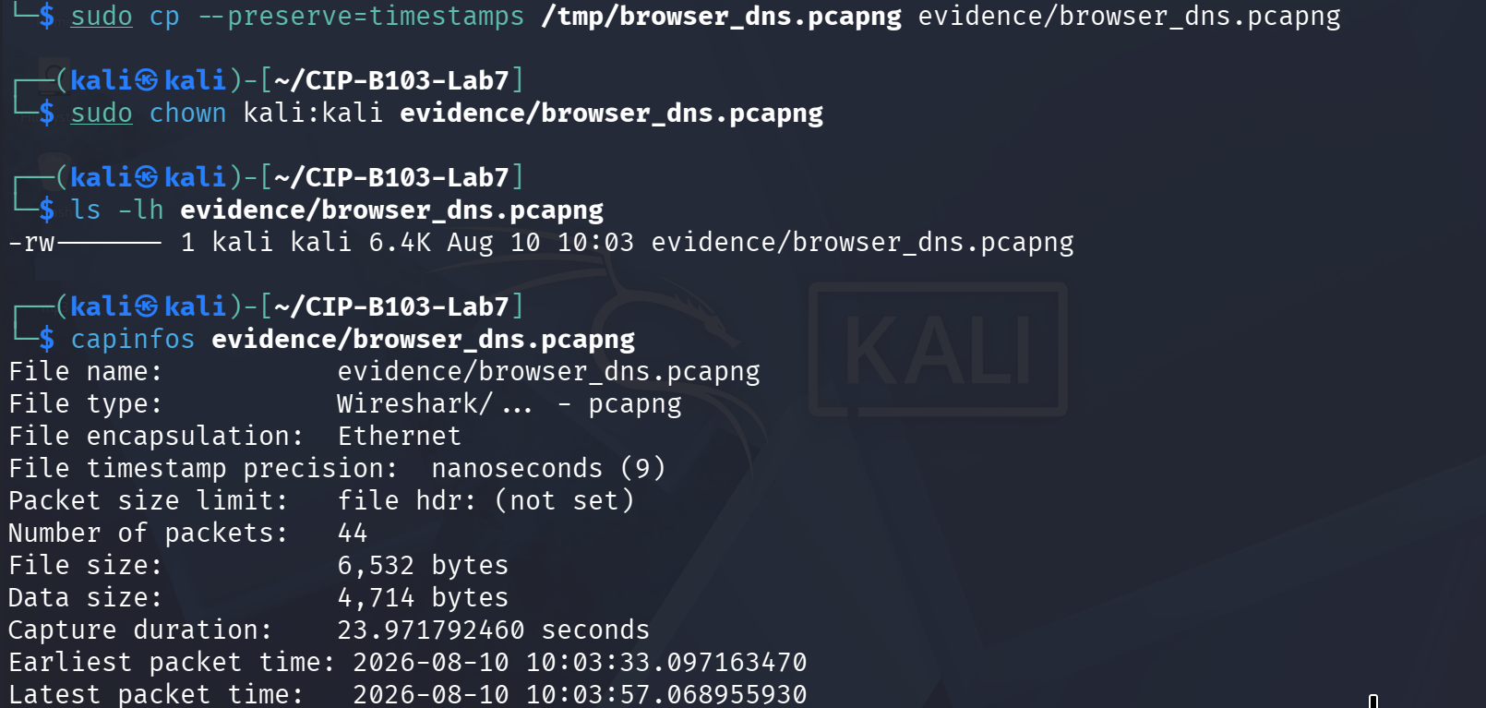
Screenshot 29: Browser capture copied to evidence/ and chown'd; capinfos re-run on the evidence copy.
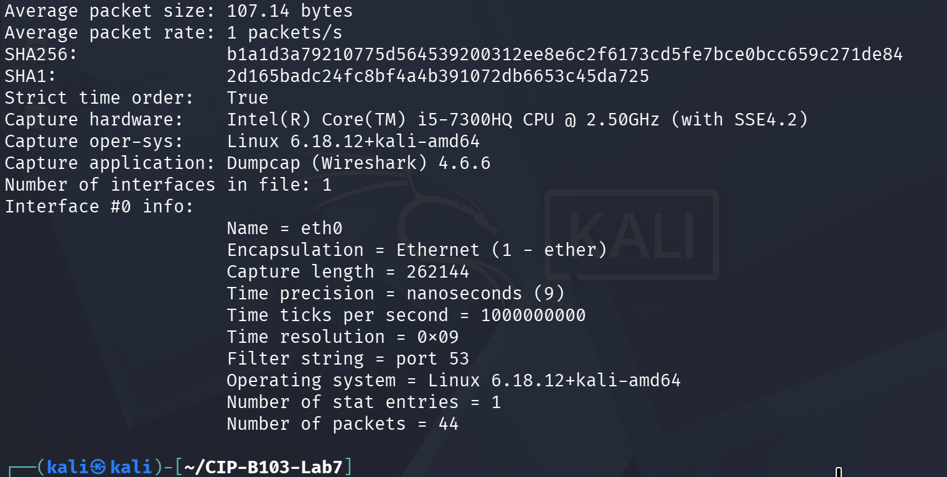
Screenshot 30: capinfos continued — SHA256/SHA1 and interface metadata for the evidence copy.
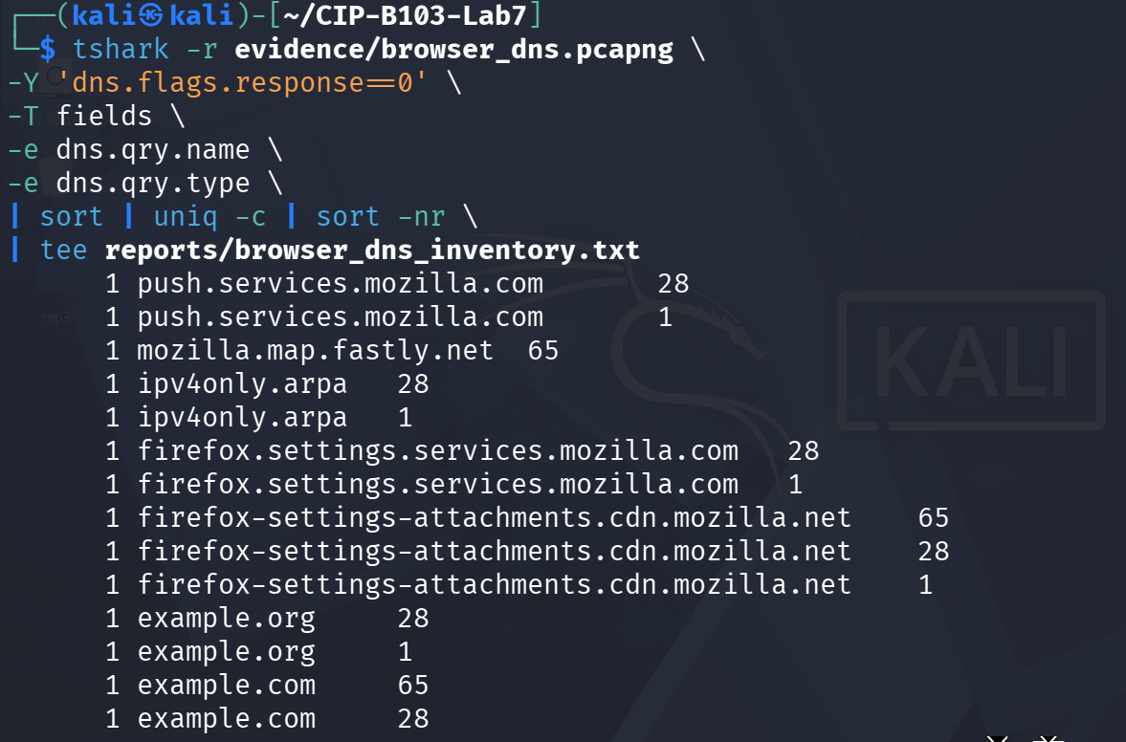
Screenshot 31: Browser DNS query inventory (sorted, deduplicated) — Mozilla telemetry/CDN and example domains.
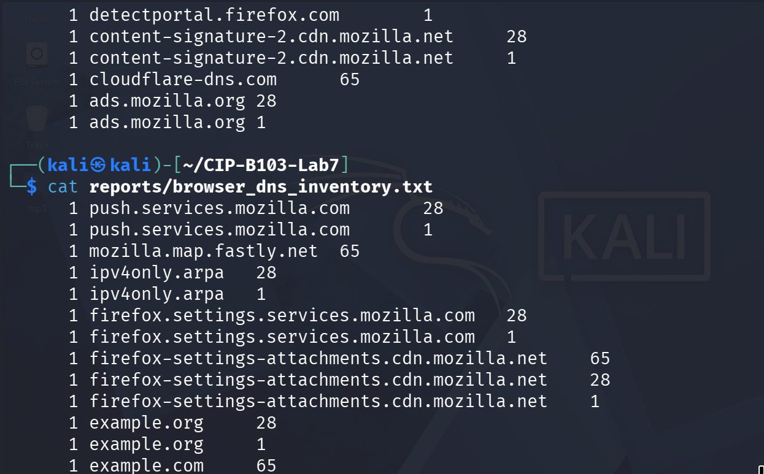
Screenshot 32: Query inventory continued, including the DoH probe to cloudflare-dns.com.
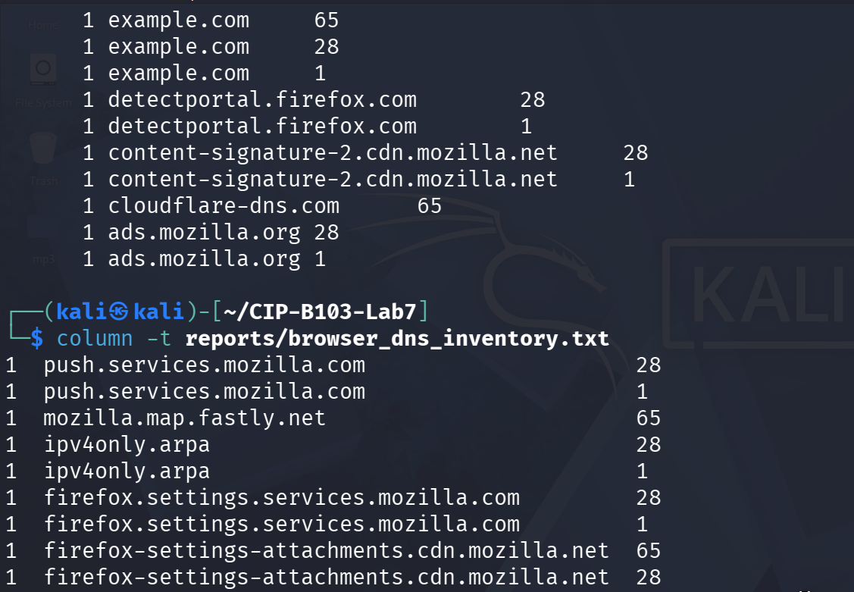
Screenshot 33: reports/browser_dns_inventory.txt contents confirmed via cat.
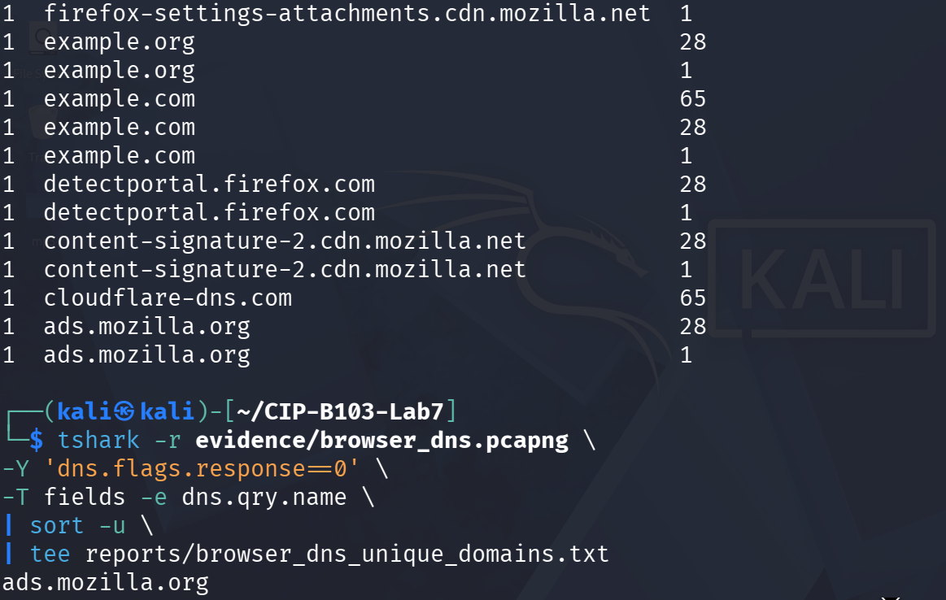
Screenshot 34: Inventory re-confirmed with column -t; unique-domain extraction started.
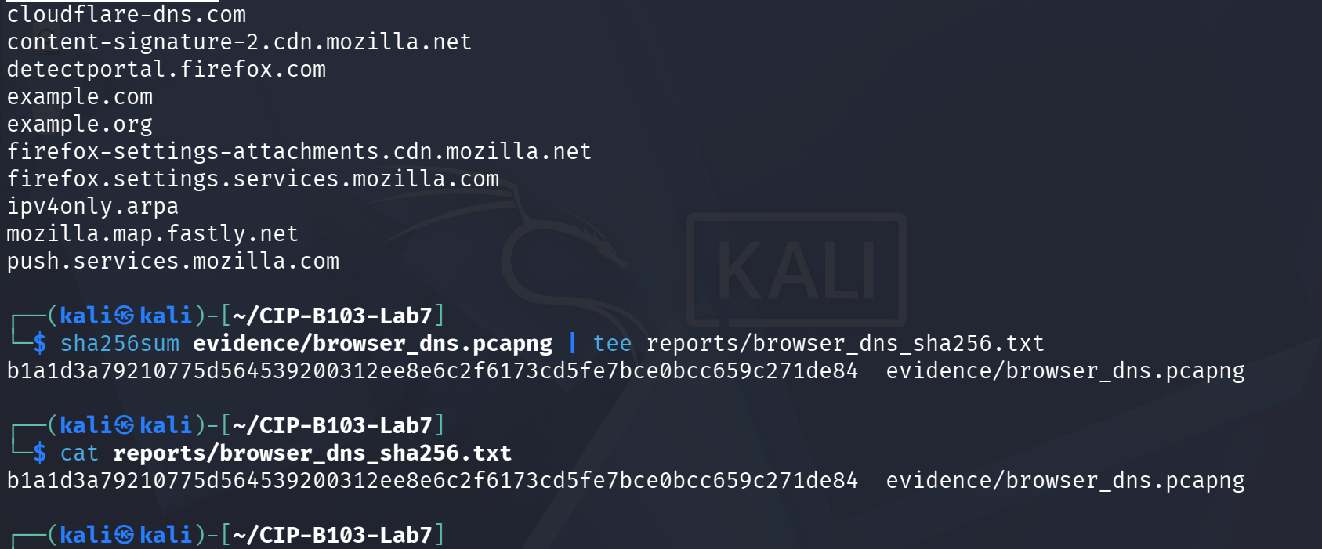
Screenshot 35: Unique domain list completed; evidence/browser_dns.pcapng SHA-256 hashed.
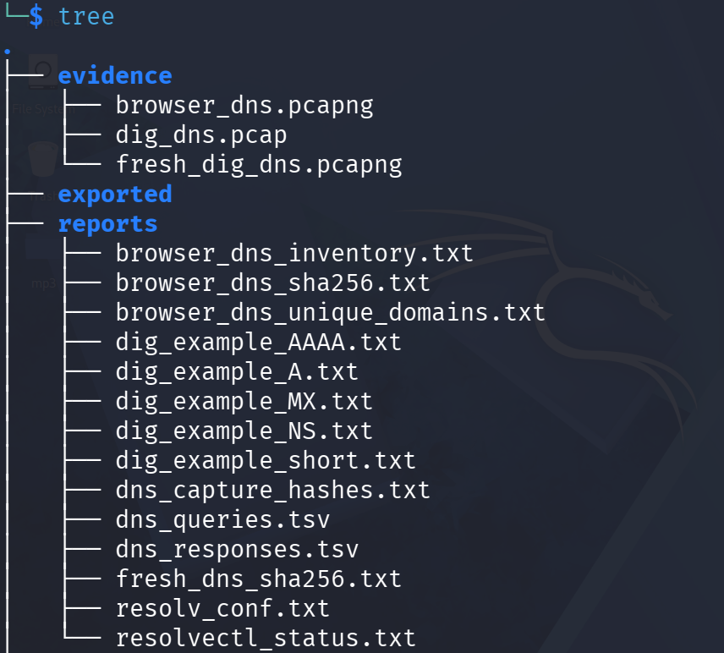
Screenshot 36: Full evidence and reports folder tree after Part E.
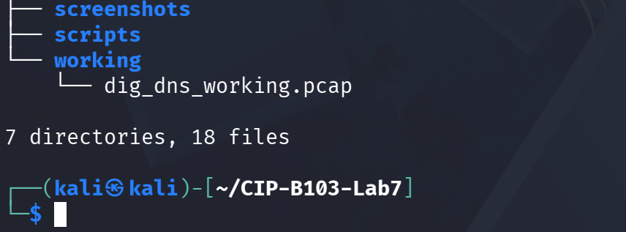
Screenshot 37: Folder tree concluded — working copy and total file count.

13. Part F - Correlate DNS with Subsequent Connections
# Extract DNS A answers
tshark -r evidence/browser_dns.pcapng -Y 'dns.a' -T fields -e frame.time_epoch -e dns.qry.name -e dns.a \
| tee reports/dns_A_answers.tsv
# Extract later TCP destinations
tshark -r evidence/browser_dns.pcapng -Y 'tcp.flags.syn==1 && tcp.flags.ack==0' -T fields \
-e frame.time_epoch -e ip.dst -e tcp.dstport \
| tee reports/subsequent_tcp_destinations.tsv
Select one DNS answer and show whether the client later initiates a connection to that IP. Explain any mismatch caused by multiple answers, proxies, CDNs, IPv6, caching or capture duration.
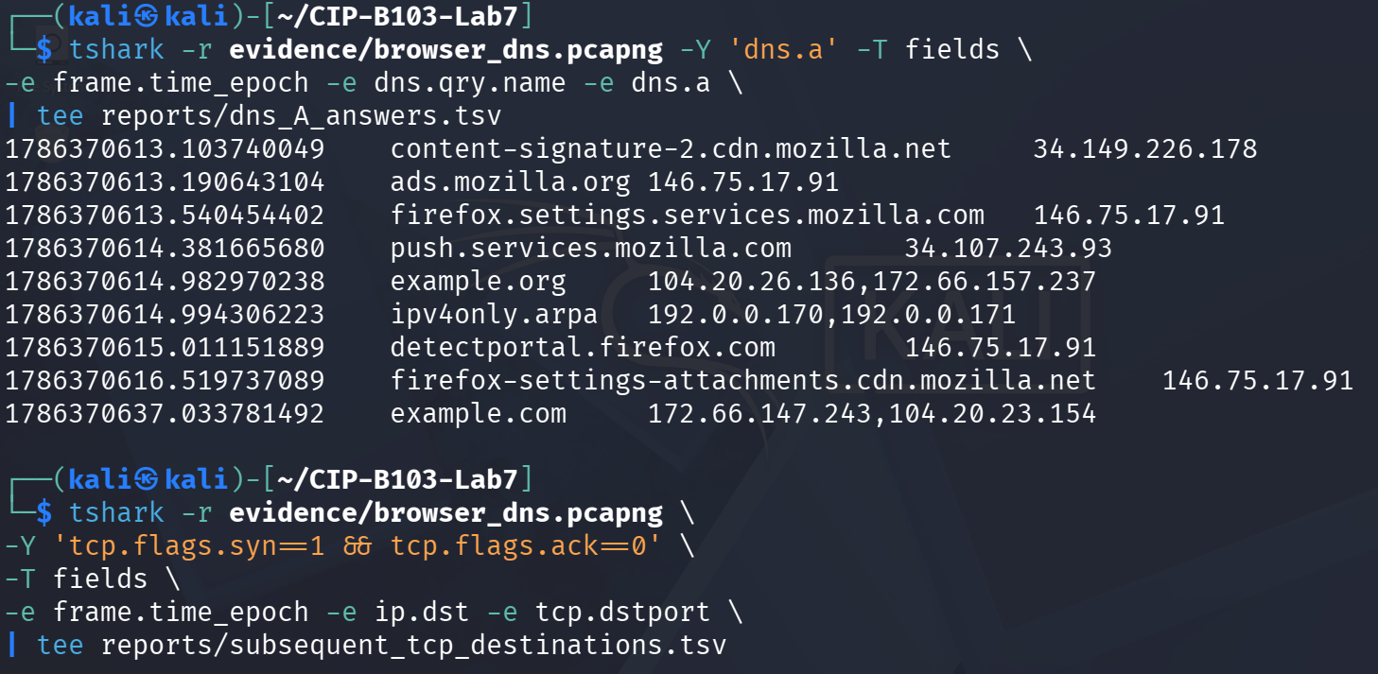
Screenshot 38: DNS A-answer extraction (dns.a) from browser_dns.pcapng, and the (empty) subsequent-TCP-destination query started.
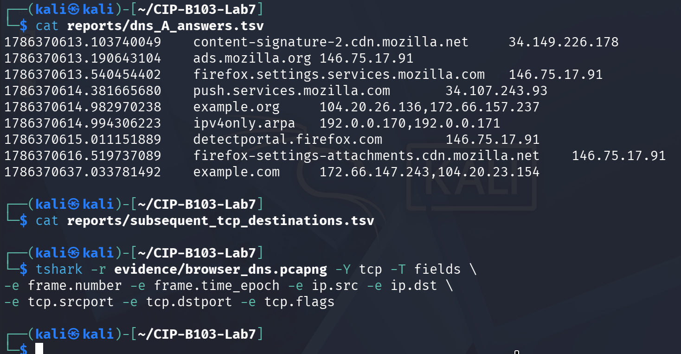
Screenshot 39: dns_A_answers.tsv contents confirmed; subsequent_tcp_destinations.tsv confirmed empty (capture was DNS-only, port 53).

14. Part G - DNS Analysis Within SMTP Evidence
If smtp.pcap from Lab 4 is available, filter dns and identify the query used to locate a mail server. Record the queried name, record type, resolver, answer and TTL.
# Optional, adjust path to your Lab 4 capture
tshark -r ../CIP-B103-Lab4/working/smtp_working.pcap -Y 'dns' -T fields \
-e frame.number -e frame.time -e dns.qry.name -e dns.qry.type -e dns.a -e dns.resp.name -e dns.resp.ttl \
| tee reports/smtp_dns_correlation.tsv
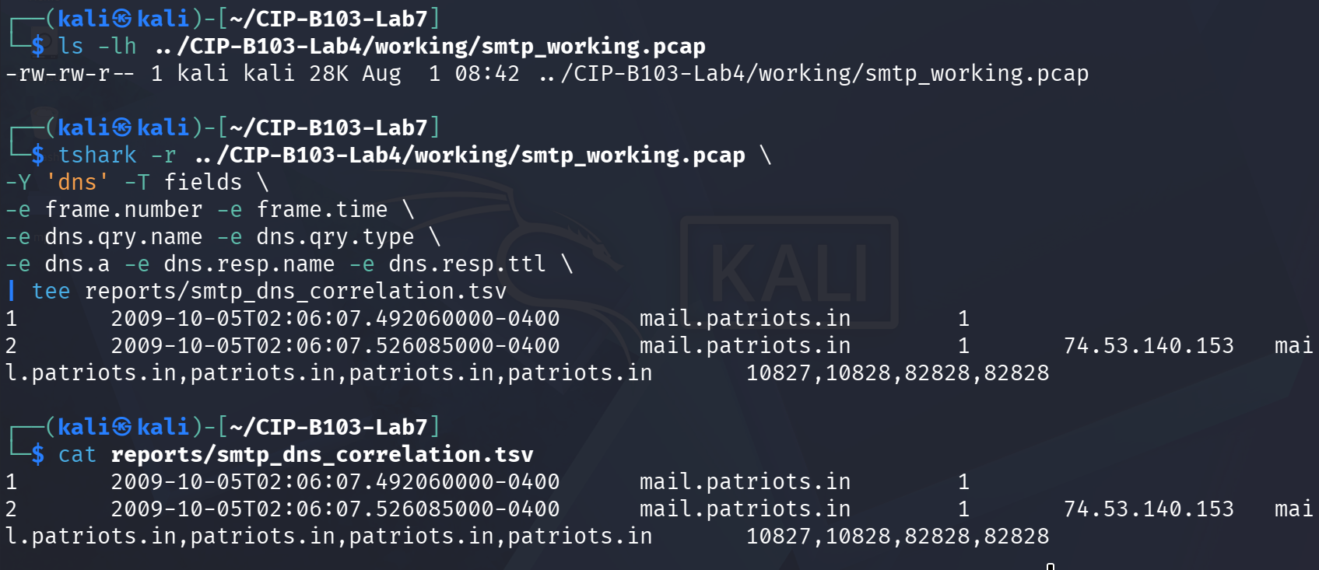
Screenshot 40: DNS records extracted from the Lab 4 smtp_working.pcap, showing the query used to locate mail.patriots.in.

15. Required Findings Worksheet
Field | Finding
Configured resolver IP | 127.0.0.53 (systemd-resolved local stub), forwarding upstream to 192.168.44.2
Client source port | 44952 (client → stub leg); 44072 (stub → upstream leg)
Resolver destination port | 53 (UDP) on both legs
Transaction ID | 0x15ad (client–stub leg); 0x0316 (stub–upstream leg) — the stub resolver assigns a new ID for the upstream query
Query name and type | example.com, type A
Response code | NOERROR (0) on both legs
Answer IP(s) | 172.66.147.243 and 104.20.23.154 (two A records, Cloudflare-hosted)
TTL | 5 seconds for both answers — a short cache lifetime, not a record creation date
Query-response time delta | ≈29.6 ms end-to-end (client query at 0.000000000 s to final stub response at 0.029639633 s); the upstream leg alone took ≈28.9 ms
Subsequent connection correlation | Not observed — reports/subsequent_tcp_destinations.tsv is empty. This is a methodological limitation, not a real absence of a connection: the browser_dns.pcapng capture filter was restricted to ‘port 53’, so no TCP traffic (including any HTTP/HTTPS connection to the resolved IPs) could ever have been recorded in that file.
Normal variations observed | Multiple A answers per query (2 IPs for example.com); a two-hop local-stub-to-upstream-resolver pattern with a different transaction ID per hop; a wide browser DNS inventory including telemetry/CDN domains (Mozilla push/settings services, content-signature CDN, DoH probe to cloudflare-dns.com, ipv4only.arpa NAT64 check) alongside the requested site; consistently short (5 s) TTLs typical of a CDN-fronted domain.

Required Screenshots Checklist
☐ Resolver configuration.
☐ dig A/AAAA/MX/NS outputs.
☐ Fresh DNS capture hash.
☐ DNS query fields.
☐ Matching DNS response fields.
☐ Transaction ID correlation.
☐ Answer and TTL.
☐ Browser query inventory.
☐ DNS answer to TCP destination correlation.
☐ Optional SMTP DNS evidence.

Student Report Template
- Executive summary.
- Resolver and environment.
- Evidence integrity.
- dig results.
- Packet-level query/response analysis.
- Transaction matching and timing.
- Browser DNS inventory.
- Connection correlation.
- Limitations and normal variations.
- Appendix.

Submission Requirements
- One PDF report named CIP-B103-Lab7_RegNo_FullName.pdf.
- The original or generated PCAP/PCAPNG evidence file and its SHA-256 hash text file.
- A reports folder containing exported CSV/TXT command output and any recovered objects.
- Screenshots must be readable, numbered and referenced in the report narrative.
- Compress the report and evidence outputs into one ZIP named with your registration number and lab number.
- Do not submit passwords or decoded credentials in public discussion channels; include them only in the protected assessment submission where required.

Marking Rubric (100 Marks)
Assessment Area | Marks | What the Instructor Will Check
Preparation and resolver identification | 10 | Correct resolver and evidence hashes.
dig record analysis | 15 | A, AAAA, MX, NS and TTL interpretation.
Packet-field extraction | 25 | Correct IDs, names, types, endpoints and response codes.
Query-response correlation | 20 | Accurate matching and timing.
Browser/connection correlation | 20 | Inventory and defensible IP connection linkage.
Report quality | 10 | Clear screenshots, tables and conclusions.

Instructor Quick Answer Guide
Checkpoint | Expected Observation
Standard transport | Usually UDP destination port 53; TCP may be used for large responses or zone transfer.
Query flag | dns.flags.response==0.
Response flag | dns.flags.response==1.
A record | IPv4 address.
AAAA record | IPv6 address.
TTL | How long a resolver may cache the record.

Command Reference Summary
Command | Purpose
dig NAME TYPE | Query a DNS record.
dns.qry.name | Queried domain name.
dns.qry.type | Requested record type.
dns.id | DNS transaction identifier.
dns.flags.rcode | Response code.
dns.resp.ttl | Answer TTL.

Academic Integrity and Authorization Statement
Student Declaration
I confirm that I completed this lab in an authorized environment, preserved the supplied evidence, did not target any third-party system, and accurately documented my own commands, observations and conclusions.

